Introduction to Amazon Elastic Block Store (Amazon EBS)

In this lab the following things were requested to be done and the outputs from commands in Task 6 to be provided:

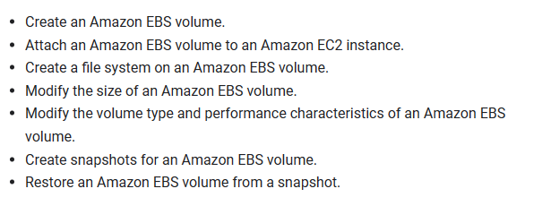

*Task 6:*

First command is for creating directory (mount point) for mounting the restored storage volume:

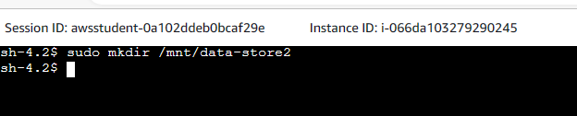

To mount the new volume the following command is used:



To display information about the block devices attached to my instance:

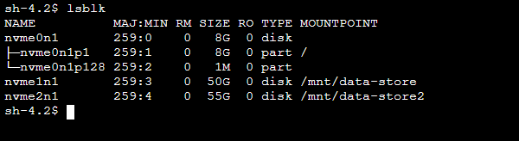

To verify the size of the file system for each volume:

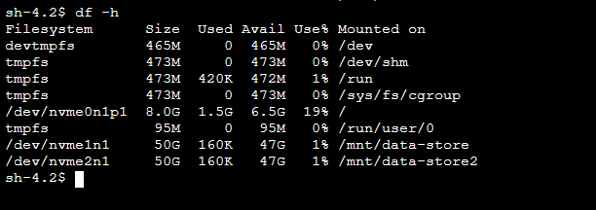

The following command is to extend the file system to use additional available capacity of the volume:

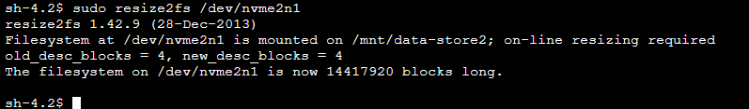

Again we verify the size of the file system for each volume:

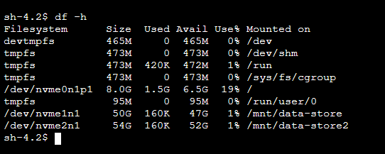

To list the contents of the volume:

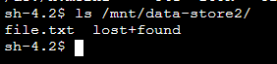

To verify the contents of file.txt are intact:



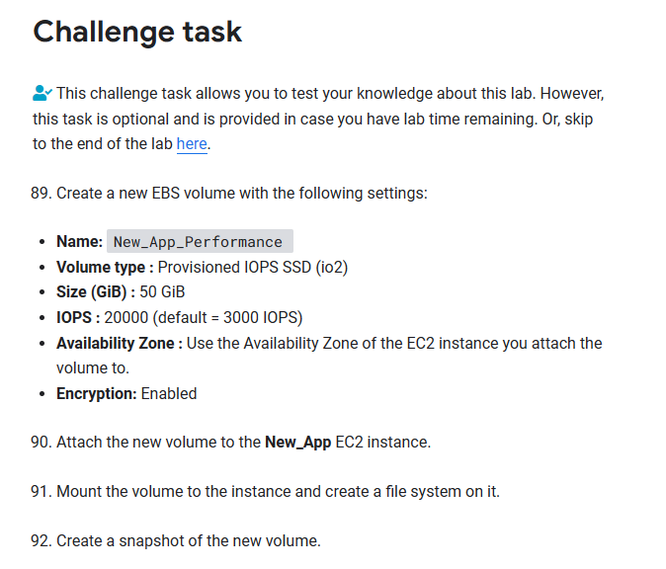

First new volume is created and instance is attached:

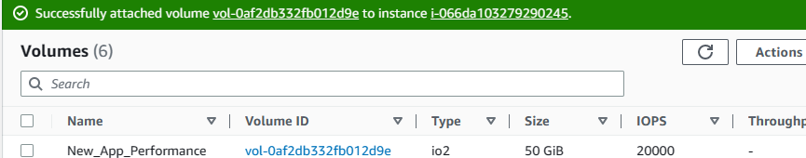

Then we connect to the terminal and to the following:

Ext3 Linux file system is created on the New_App_Performance EBC Volume:

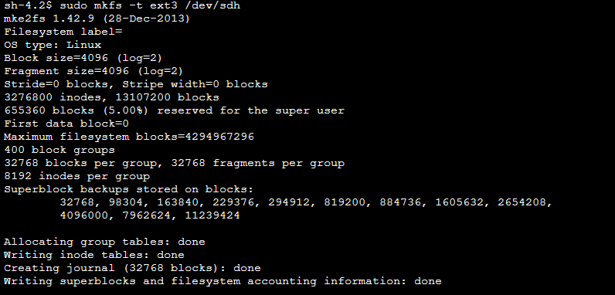

Next commands are for creating new directory for mounting the New_App_Performance storage Volume, to mount the new storage volume, to add line to the end of /etc/fstab file, then we view the file:

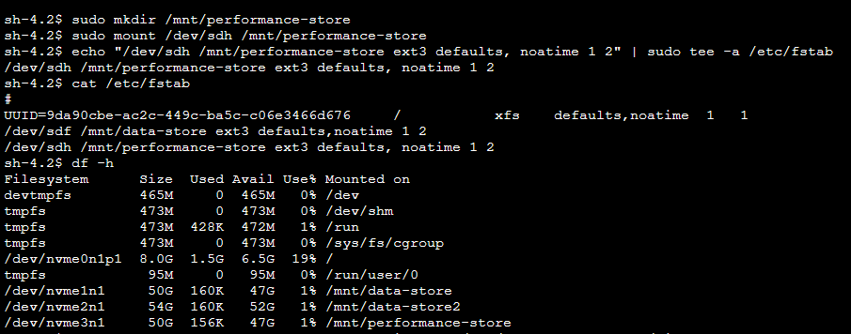

Next a new text file is created on the newly mounted volume and we view the contents of that file:

